Version 1.0



**Group Id: Bc190401150**

**Supervisor Name: Abdullah Qamar**

Revision History

|  |  |  |  |
| --- | --- | --- | --- |
| Date (dd/mm/yyyy) | Version | Description | Author |
| 4/10/24 | 1.0 | This document will contain the introductory lines regarding my project. It will contain the scope of the project that is being developed. Scope of the project will be explained on the basis of requirements (Functional and Non-Functional) are related to project that will be developed.  A Use Case Diagram is also present in this document. It explains that how a user will act and work on this software. Its complete steps are given in this document and usage scenarios explain that how a Use will work.  At the end, we also explained working methodology and work flow chart. | Bc190401150 |
|  |  |  |  |
|  |  |  |  |
|  |  |  |  |

Table of Contents

1. Scope (of the project)
2. Functional Requirements Non Functional requirements
3. Use Case Diagram
4. Usage Scenarios
5. Adopted Methodology
6. Work Plan (Use MS Project to create Schedule/Work Plan)

**SRS Document**

**Scope of Project:**

An autism app is a digital application designed to support individuals on the autism spectrum, as well as their caregivers, therapists, and educators. These apps typically offer tools and resources that address the unique challenges faced by people with autism, helping them in various aspects of daily life, communication, social interaction, and emotional regulation.

Users can easily create accounts, either by themselves or with help from a caregiver. They just need to provide basic information like their name, email, and password, and they also have the option to upload a profile picture.

This app supports various aspects of daily life, communication, emotional regulation, and the development of social skills.  
The app offers sensory support resources like calming exercises and content that is friendly for different senses. It also includes communication tools, such as customizable boards and visual aids, to meet each person’s preferences and needs.

**Functional and non Functional Requirements:**

**Functional Requirements:**

1. **User Registration:**

* Users can create accounts by entering important information like their name, email, password, and, if they want, a profile picture.
* If someone needs help, parents or guardians can register for them.

1. **User Login:**

A login system keeps user information safe, making sure that only allowed people can access their accounts. It also saves preferences and settings, so users don’t have to set them up again each time they use the app.

1. **User Profiles:** Users should be able to create and update their profiles with important personal details, such as preferences, sensitivities, and communication needs. This helps in providing a personalized and comfortable experience.
2. Sensory Support:

It helps individuals on the autism spectrum manage their sensory experiences.The aim of this support is to create a more comfortable environment for users, enabling them to navigate efficiently.

The main components of sensory support are: sensory regulation, such as comfort, and sensory-friendly materials

1. **Communication Tools:**

AAC methods support communication for people with speech or language impairments..

* **Picture Exchange Communication System**: The **Picture Exchange Communication System (PECS)** is a way for people who cannot speak or have trouble speaking to use pictures to show what they think, need, or want.
* Speech-Generating Devices (SGDs): Electronic devices that speak words or sentences when the user picks symbols or types in text.There are electronic devices that help people who have difficulty speaking.

1. **Task Management:** The app should provide task scheduling and reminder features to help users and caregivers manage daily routines and time effectively. Users can set tasks with specific times.
2. **Social Skills Training:** Interactive modules and activities should be available to help users practice social skills and emotional understanding. These can include virtual scenarios where users can practice social interactions in a safe, simulated environment.

**Non-Functional Requirements:**

1. **Usability:** The app should have a simple and easy-to-use design that everyone can navigate, no matter their age or skills. There should be clear instructions and help options to guide users in using all the app features.
2. **Performance**: The app should open quickly and respond fast when users navigate or access information. It should be able to handle many users at the same time without crashing or slowing down.
3. **Security:** User data should be stored safely and protected from unauthorized access using encryption and secure login methods. The app should follow data protection rules to keep user information private and confidential.
4. **Reliability:** The app should work smoothly and not crash or have errors often. It should also have a backup system to recover data if something goes wrong unexpectedly.
5. **Scalability:** The app should be able to handle more users and data without slowing down. It should also allow for easy updates and new features to be added in the future.
6. **Accessibility:** The app should follow accessibility guidelines so that people with different disabilities can use it easily. It should include features like text-to-speech, adjustable font sizes, and high-contrast colors to help all users.

**Use Case Diagram(s):**

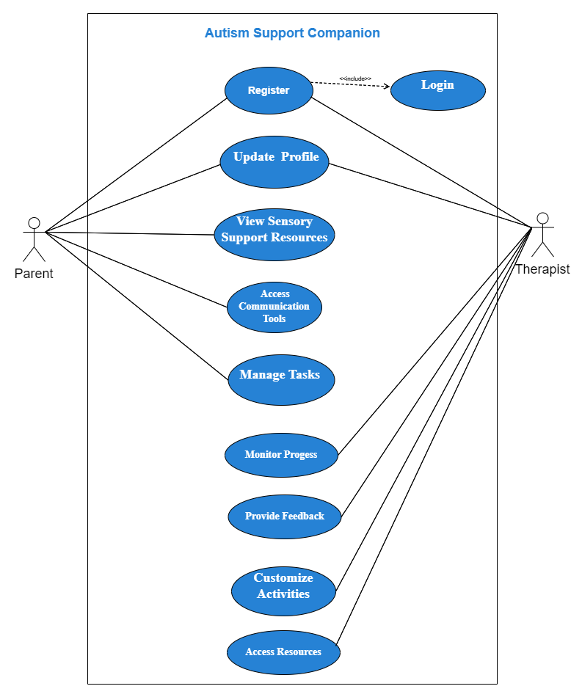

**Usage Scenarios:**

### Register Account

|  |  |
| --- | --- |
| **Use Case Title** | **Register Account** |
| Use Case ID | UC-01 |
| Actions | 1. User opens the app. |
| Description | The user selects the option to register a new account. |
| Alternative Paths | User cancels the registration process. |
| Pre-Conditions | The app is installed on the user's device. |
| Post-Conditions | A new account is successfully registered. |
| Author | Bc190401150 |
| Exceptions | Invalid input, such as existing email or weak password. |

**Log In**

|  |  |
| --- | --- |
| **Use Case Title** | **Log In** |
| Use Case ID | UC-02 |
| Actions | 1. User opens the app. |
| Description | The user enters their credentials and selects the login option. |
| Alternative Paths | User cancels the login process. |
| Pre-Conditions | The app is installed on the user's device. |
| Post-Conditions | The user is securely logged in and directed to the home screen. |
| Author | Bc190401150 |
| Exceptions | Incorrect username or password. |
|  |  |

**Update Profile**

|  |  |
| --- | --- |
| **Use Case Title** | **Update Profile** |
| Use Case ID | UC-03 |
| Actions | 1. User navigates to the profile section. |
| Description | The user selects the option to edit their profile. |
| Alternative Paths | User cancels the profile update process. |
| Pre-Conditions | The user is logged in and has an existing profile. |
| Post-Conditions | The user's profile is successfully updated with the new information. |
| Author | Bc190401150 |
| Exceptions | None. |

**Sensory Support Resources**

|  |  |
| --- | --- |
| **Use Case Title** | **View Sensory Support Resources** |
| Use Case ID | UC-04 |
| Actions | 1. User navigates to the sensory support section. |
| Description | The user explores the available tools and resources for sensory regulation. |
| Alternative Paths | User cancels the browsing process. |
| Pre-Conditions | The user is logged in and has access to the sensory support section. |
| Post-Conditions | The user can access various sensory support resources. |

**Access Communication Tools**

|  |  |
| --- | --- |
| **Use Case Title** | **Access Communication Tools** |
| Use Case ID | UC-05 |
| Actions | 1. User accesses the communication tools section. |
| Description | The user selects the desired communication tool, such as a customizable board. |
| Alternative Paths | User cancels the selection process. |
| Pre-Conditions | The user is logged in and has access to the communication tools section. |
| Post-Conditions | The user can utilize the selected communication tool. |
| Author | Bc190401150 |
| Exceptions | None. |

**Manage Tasks**

|  |  |
| --- | --- |
| **Use Case Title** | **Manage Tasks** |
| Use Case ID | UC-06 |
| Actions | 1. User navigates to the tasks section. |
| Description | The user adds, edits, or deletes tasks as needed, setting reminders for important activities. |
| Alternative Paths | User cancels the task management process. |
| Pre-Conditions | The user is logged in and has access to the tasks section. |
| Post-Conditions | The user's tasks are successfully managed with reminders set as required. |
| Author | Bc190401150 |
| Exceptions | None. |

**Engage in Social Skills Training**

|  |  |
| --- | --- |
| **Use Case Title** | **Engage in Social Skills Training** |
| Use Case ID | UC-07 |
| Actions | 1. User accesses the social skills training module. |
| Description | The user selects a social skills training activity or module to engage with. |
| Alternative Paths | User cancels the selection process. |
| Pre-Conditions | The user is logged in and has access to the social skills training section. |
| Post-Conditions | The user actively participates in the selected social skills training activity. |
| Author | Bc190401150 |
| Exceptions | None. |

**Adopted Methodology**

**Available Methodologies:**

There are the following methodologies:

• Build-and-fix model

• Waterfall model

• Rapid prototyping model

• Incremental model

• Extreme programming

• Synchronize-and-stabilize model

• Spiral model

• Object-oriented life-cycle models

**CHOSEN METHODOLOGY:**

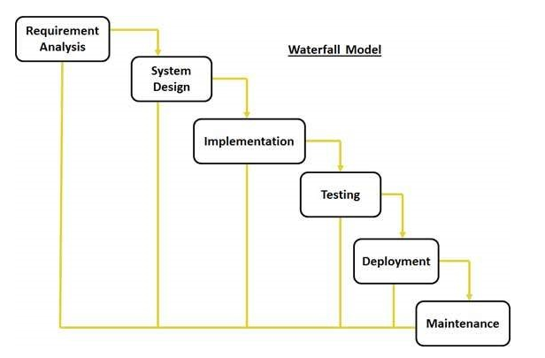

Different methodologies and models are used by the people according to their work and planning. We will use “VU process model” It is combination of two models Water Fall and Spiral methodologies.

### ****Waterfall Model****

The **Waterfall Model** is a structured, step-by-step approach to software development, where each phase flows logically into the next. It is called "waterfall" because it is like water cascading down a series of steps.

1. **System Requirements**: Gather and define all the requirements for the project.
2. **Analysis**: Understand the problem and plan how to approach it.
3. **Design**: Create a blueprint of the system based on the analysis.
4. **Coding**: Write the actual code to build the system.
5. **Testing**: Verify that the system works as expected.
6. **Maintenance**: Fix any issues after the system is deployed and make improvements.

**Implementation**

**Maintenance**

**Testing**

**Requirement Analysis**

**System Design**

**Conclusion:**

The Waterfall Model focuses heavily on documentation, making maintenance easier due to detailed records. However, client feedback is typically received only after the product is fully delivered. This can lead to issues if there are errors in the initial requirements, as these may not be identified until late in the process. As a result, the model can cause significant time and cost challenges when corrections are needed.

**Spiral Model:**

This model was developed by Barry Boehm. The main idea of this model is to avert risk as there is always an element of risk in development of software. For example, key personnel may resign at a critical juncture, the manufacturer of the software development may go bankrupt, etc.

Plan Next Phase

Determine objectives, alternatives, constraints

Identify and resolve risks

Develop and verify next-level product

In its simplified form, the Spiral Model is Waterfall model plus risk analysis. In this case each stage is preceded by identification of alternatives and risk analysis and is then followed by evaluation and planning for the next phase. If risks cannot be resolved, project is immediately terminated.

Rapid Prototype

Specification

Design

Implementation

Risk Analysis

Verify

**Conclusion:**

As can be seen, a Spiral Model has two dimensions. Radial dimension represents the cumulative cost to date and the angular dimension represents the progress through the spiral. Each phase begins by determining objectives of that phase and at each phase a new process model may be followed. The main strength of the Spiral Model comes from the fact that it is very sensitive to the risk. Because of the spiral nature of development, it is easy to judge how much to test and there is no distinction between development and maintenance. It however can only be used for large-scale software development and that too for internal (in-house) software only.

**The VU Process Model** combines the Waterfall and Spiral models. Each stage of the Waterfall approach is preceded by identifying alternatives and analyzing risks, followed by evaluation and planning for the next phase.

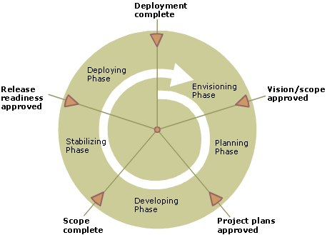

**Reasons for choosing the Methodology**

It derives the benefits of predictability from the milestone-based planning of the waterfall model, as well as the benefits of feedback and creativity from the spiral model.

* The VU Process Model is a documentation-driven model. It therefore generates complete and comprehensive documentation and hence makes the maintenance task much easier because the feedback of user must fulfil on each phase of development.
* .VU Process Model is heavily dependent on risk analysis and evaluation in each phase.
* Progress Tracking and Risk management is easy in this process.
* Project can be divided into small units and thus the Object-Oriented Approach for web based application can easily be implemented.
* The modules or prototypes which are successfully developed can be implemented independently and can be easily integrated.
* The deadline for the given project is good enough to be build. So we can easily choose selected methodology to work upon.

**Work Plan (Use MS Project to create Schedule/Work Plan)**

